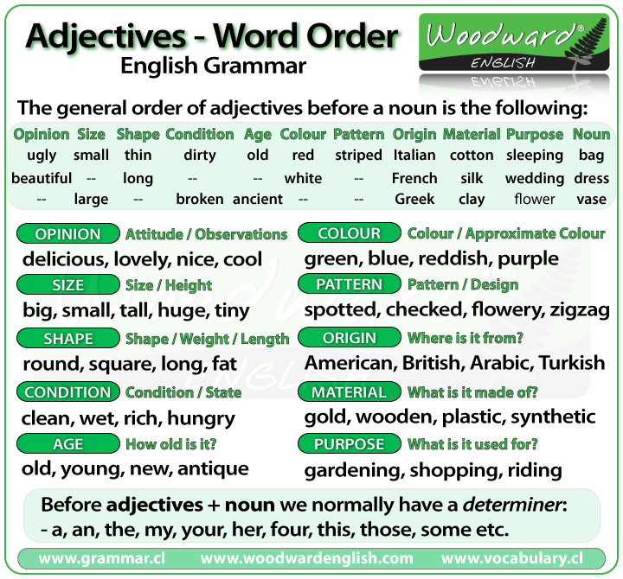/marlonbravo2014thiep

Sometimes we use **more than one** adjective in front of a noun:

He was a nice intelligent young man.  
She had a small round black wooden box.

**Opinion adjectives:**

Some adjectives give a **general opinion**. We can use these adjectives to describe almost any noun:

|  |  |  |  |
| --- | --- | --- | --- |
| good | bad | lovely | strange |
| beautiful | nice | brilliant | excellent |
| awful | important | wonderful | nasty |

 Some adjectives give a **specific opinion**. We only use these adjectives to describe particular kinds of noun:

**Food**: tasty; delicious  
**Furniture, buildings**: comfortable; uncomfortable  
**People, animals**: clever; intelligent; friendly

We usually put a **general** opinion **in front of a specific** opinion:

Nice tasty soup.  
A nasty uncomfortable armchair  
A lovely intelligent animal

Usually we put an adjective that gives an **opinion in front** of an adjective that is **descriptive**:

a nice red dress; a silly old man; those horrible yellow curtains

We often have **two** adjectives in front of a noun:

a handsome young man; a big black car; that horrible big dog

Sometimes we have **three** adjectives, but this is **unusual**:

a nice handsome young man;  
a big black American car;  
that horrible big fierce dog

It is **very unusual** to have **more than three** adjectives.

Adjectives usually come in this order:

| **1** | **2** | **3** | **4** | **5** | **6** | **7** | **8** |
| --- | --- | --- | --- | --- | --- | --- | --- |
| General opinion | Specific opinion | Size | Shape | Age | Colour | Nationality | Material |

We use some adjectives only **after a link verb**:

|  |  |  |  |
| --- | --- | --- | --- |
| afraid | alive | alone | asleep |
| content | glad | ill | ready |
| sorry | sure | unable | well |

Some of the commonest ***-ed*** adjectives are normally used only **after a link verb**:

***annoyed;  finished;  bored; pleased; thrilled***

We say:

Our teacher was ill.  
My uncle was very glad when he heard the news.  
The policeman seemed to be very annoyed

but we do not say:

We had an ~~ill~~ teacher.  
When he heard the news he was ~~a very glad uncle~~  
He seemed to be a ~~very annoyed policeman~~

A few adjectives are used **only in front of a noun**:

|  |  |  |  |
| --- | --- | --- | --- |
| north south east west | northern southern eastern western | countless occasional lone | eventful indoor outdoor |

We say:

He lives in the **eastern** district.  
There were **countless** problems with the new machinery.

but we do not say:

~~The district he lives in is eastern~~  
~~The problems with the new machinery were countless~~.

- See more at: http://learnenglish.britishcouncil.org/en/english-grammar/adjectives/order-adjectives#sthash.qay8SFPT.dpuf